האוניברסיטה העברית בירושלים

הפקולטה לחקלאות, מזון וסביבה ע"ש רוברט ה. סמית

**תכנית מחקר המוגשת לאישור כתכנית לעבודת- דוקטור**

**תאריך הגשת התכנית: 12.17.2015**

**שם התלמיד:**

תומר מלחי Tomer Malchi

**שם המדריך:**

פרופ' בני חפץ Prof. Benny Chefetz

פרופ' משה שנקר Prof. Moshe Shenker

**נושא העבודה:**

תרופות פסיכואקטיביות בצמחים: פרמוקינטיקה ופרמודינמיקה

Psychoactive drugs in plants: Pharmacokinetics and Pharmacodynamics.

הרינו מאשרים את הנושא ואת התוכנית, ומסכימים להדריך את המועמד בביצוע עבודה זו.





בני חפץ משה שנקר

**Abstract**

To meet mounting water demands, treated wastewater has become an important source of irrigation. Thus, contamination of treated wastewater by persistent pharmaceutical compounds and their fate in the agricultural environment are of increasing concern. This study focuses on a specific group of pharmaceuticals, psychoactive drugs, which are designed to act on the central nervous system and alter behavior and cognition. The site of action of psychoactive drugs is the brain hence they must have specific physic­­ochemical properties that enable penetration across the blood brain barrier. Slightly lipophilic compounds are capable of passive diffusion across the blood brain barrier; thus this study hypothesizes that compounds which are capable of passively diffusing into the brain will passively diffuse past the casparian strip and into the plant vascular system. Compounds which are capable of crossing the casparian strip and reach the xylem vessels will be taken up passively from the root to the shoot with the transpiration stream. Thus psychoactive drugs that are present in treated wastewater used for irrigation are expected to be taken up and may accumulate in plant leaves.

The study will use a hydroponic system to examine uptake, translocation and metabolism of selected psychoactive drugs (benzodiazepines and anti-epileptics pharmaceuticals). The study will evaluate the plant-drug interaction using a medicinal chemistry perspective that will examine both the pharmokinetics (what the plant does to the drug) and pharmodynamics (what the drug does to the plant). The study will evaluate drug drug interactions and their effect on uptake, translocation and metabolism. The study will examine possible concentration dependent effects of different psychoactive drugs. Both C3 plants (cucumber and tomato) and C4 plants (sorghum, and maize) will be utilized for a more informative understanding of mechanism involved. The study will quantify the compound concentrations in the nutrient solution, roots, shoot and the xylem sap. The study will quantify compound metabolites and evaluate growth, nutrient concentrations, plant hormones, enzymes and signal transduction molecules (e.g. gamma-amino butyric acid) in order to understand the drug's effect on the plant, drug metabolisms and mechanisms involved in the drug-plant interaction.

1. **Introduction**

The persistence of pharmaceutical in treated wastewater has been well documented in multiple studies (Clara et al., 2005; Nakada et al., 2006; Yu et al., 2006; Miège et al., 2009; Kasprzyk-Hordern et al., 2009; Wick et al., 2009; Sui et al., 2011; Behera et al., 2011; Gracia-Lor et al., 2012). Pharmaceuticals that are excreted from the human body after ingestion enter the sewage stream where they are treated in wastewater treatment plants. Hence the use of treated wastewater for irrigation may result in exposure of these compounds into the agricultural environment if the compounds are not fully removed during wastewater treatment.

Psychoactive drugs have been detected in treated wastewater; it has been shown that these compounds may be only partially removed during the wastewater treatment process(Jelic et al., 2011; Hass et al., 2012; Subedi and Kannan, 2015). The anti-epileptic carbamazepine and its metabolites are commonly detected in treated wastewater, and studies have shown the compound to be taken up and partly metabolized in the plants when treated wastewater is used for irrigation (Malchi et al., 2014; Goldstein et al., 2014). Other antiepileptic drugs have also been reported in treated wastewater, for example in South Korea phenytoin was found in the range of 8.8-181 ng/L in treated wastewater following biological membrane reactor treatment and membrane filtration (Kim et al., 2007). Gabapentin was detected at a concentration range of 3.0 to 42.6 µg/L treated wastewater during a 5 month campaign in the UK where samples collected following either biological treatment with a trickling bed filter or activated sludge treatment. In the same study carbamazepine was detected at a range of 0.6 to 4.6 µg/L(Kasprzyk-Hordern et al., 2009).

Although there are ample studies documenting the ubiquity of these compounds, only few studies have reported on their fate in the agricultural environment or their potential to be taken up and metabolized by plants. Since this class of pharmaceuticals act on the central nervous system altering behavior and cognition, several studies have examined environmental exposure of these compounds and related adverse effects on different organisms (Brooks et al., 2003; Thomas and Klaper, 2012). Benzodiazepines have been shown to affect gene expression and behavior in different types of fish, even at environmentally relevant concentrations of several hundred ng/L (Oggier et al., 2010; Brodin et al., 2013). Carbamazepine has been shown to affect plant development, with changes in nutrient and plant hormone concentrations, at environmentally relevant concentrations of low as 0.005 mg/kg soil (Carter et al., 2015).

In order to better understand the fate of pharmaceuticals in the environmental, the focus of this study is to examine the fate of psychoactive drugs relative to their pharmacological class of antiepileptic drugs (AEDs) and structural class of benzodiazepines (BDZs; Figure 1) and to investigate their interaction with plants.

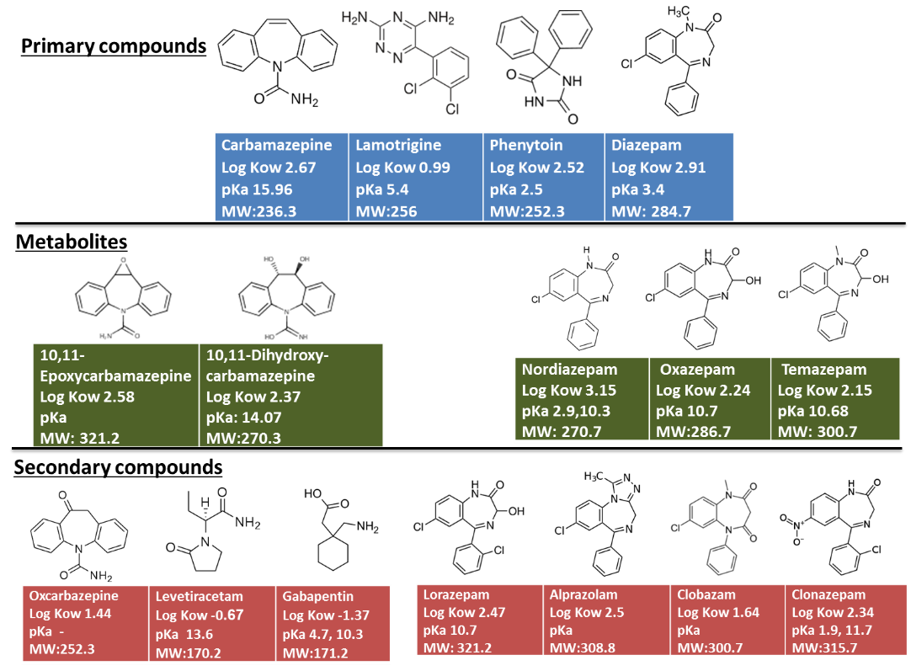

Figure 1. Structure and selected physicochemical properties of the selected psychoactive drugs.

* 1. **The - blood-brain barrier and the casparian strip**

Psychoactive drugs most often cross from the bloodstream to the brain based on passive diffusion of the blood-brain barrier. The blood-brain barrier is composed of endothelial cells that are connected by tight junctions which are formed from transmembrane proteins and cytoplasmic accessory proteins forming a seal between the endothelial cells (Liu et al., 2012). The seal creates a barrier that separates the bloodstream from the extracellular space in the brain, protecting the brain from toxic compounds. Molecules must enter the endothelial cells in order to enter the brain tissue forcing molecules to pass through a cell membrane. Passive diffusion is considered to be the main mechanism by which psychoactive drugs enter the brain (Eyal et al., 2009).

In plants the casparian strips has a similar function to that of the tight junctions. The casparian strips are specially modified primary cell walls with high lignin and suberin content that are located at the endodermis of vascular plant roots and limit transport into the vascular tissue. The cell membrane of the endodermal cells are tightly attached to the primary cell wall at the casparian strip which forms a tight barrier that forces solutes to pass through the cell membranes and into the symplastic route in order to pass to the vascular tissue (Enstone et al., 2003; Chen et al., 2011). The tight junctions in the blood brain barrier and the casparian strip in the plant roots are biological barriers restricting transport of compounds.

The study will examine the relationship between passive diffusion of drugs across the blood-brain barrier (Dehouck et al., 1992; Fischer et al., 1998; Pardridge, 2007) and uptake and translocating of drugs in plants with the transpiration stream. Research has suggested that the optimum octanol/water partition (*Kow*) values for drugs that cross the blood brain barrier by diffusion are between log K*ow* 1-4 (van de Waterbeemd et al., 1998) which match the range for optimum *Kow* values suggested for plant translocation (Briggs et al., 1982; Hsu et al., 1990). Other physicochemical properties such as ionic charge, molecular weight, tertiary structure and degree of protein binding should also be considered in this comparison as they influence blood-brain barrier penetration (Banks, 2009). Lipid-soluble compounds with low protein binding are capable of crossing these barriers, hence their accumulation in the brain is dependent on blood flow in the bloodstream, and in the plant the dependence is on the plant transpiration rate(Laterra et al., 1999). The study will examine the uptake and translocation of psychoactive compounds and aim to draw parallels between plant uptake and passage into the brain.

* 1. **Antiepileptic drugs**

Antiepileptic drugs prevent or reduce the severity and frequency of seizures. In addition to epilepsy these drugs are prescribed for bipolar disorder, anxiety, insomnia, multiple sclerosis, schizophrenia and other psychotic disorders (Cascade et al., 2008). There are different structural and functional classes of anticonvulsants with a variety of chemical properties and modes of action, which target neurotransmitters, receptors, enzymes and ion channels (Lasoń et al., 2011). The most commonly prescribed AEDs such as carbamazepine, phenytoin and lamotrigine primarily reduce neuronal excitability by blocking sodium or calcium channels (Sirven et al., 2012). In accordance, this study will examine the effect of antiepileptic drugs on nutrient content, plant hormones and plant physiology in order to understand if the compounds interact with plant ion channels, thus affecting membrane action potential, corresponding to the compound activity in the mammalian brain.

Table 1. Recommended dosage for adults of selected anticonvulsant drugs (Bernus et al., 1997; Curry and Kulling, 1998; Salem et al., 2004; FDA, 2013; Bergman, 2014).

|  |  |  |  |
| --- | --- | --- | --- |
| Anticonvulsant | Subgroup | Dosage (mg/day) |  |
| Clonazepam | Benzodiazepine | 0.5-4 |  |
| [Lorazepam](http://www.drugs.com/lorazepam.html) | Benzodiazepine | 1-4 |  |
| Alprazolam | Benzodiazepine | 1-6 |  |
| Diazepam | Benzodiazepine | 5-40 |  |
| Oxazepam | Benzodiazepine | 10-40 |  |
| Lamotrigine | Triazine | 25-50 |  |
| Phenytoin | Hydantoin | 200-600 |  |
| Carbamazepine | Dibenzazepine | 100-1200 |  |
| Gabapentin | GABA analogs | 900-1800 |  |
| Levetiracetam | Pyrrolidine | 1000-3000 |  |

The different anticonvulsants vary in their recommended daily dose, as well as the percent metabolized in the human body. Dosage may vary from 0.5 mg per day (clonazepam) to several grams per day (levetiracetam), hence we expect the compounds to have different activity at different concentrations. This study will examine the dosage response of different plants to the selected AEDs. In the body AEDs are metabolized and excreted, however in plants there is no excretion route, hence we will investigate plant metabolism of pharmaceuticals and identify compound metabolites in plants. Furthermore, anticonvulsant are often recommended in combination with other anticonvulsants which can significantly affect their metabolic and excretion rates due to drug-drug interaction (Bernus et al., 1997; Curry and Kulling, 1998; Salem et al., 2004; Eyal et al., 2009). For example studies have shown that when carbamazepine is prescribed together with lamotrigine there was a significant increase in the ratio of carbamazepine-10,11-epoxide to the parent compound (Warner et al., 1992). We will examine how exposure to multiple AEDs influences the uptake, translocation and metabolism of these compounds.

* 1. **Benzodiazepines**

Benzodiazepines (BZDs) are a chemical class of drugs used as sedatives, hypnotics, anxiolytics, anticonvulsants and muscle relaxants. BZDs are some of the most prescribed drugs in the United States, 3 of the top 10 most commonly prescribed psychotic drugs in 2009 with worldwide sales estimated at $880 billion. The dosage of BZDs range from several hundred micrograms to 10s of milligrams, Table 1 (Bergman, 2014).

The basic structure of BZDs is a benzene ring fused to a seven-member 1, 4-diazepine ring. Most BZDs have a 5-aryl substituent ring with different functional groups substituted at positions 1, 2, 3, 4 of the diazepine ring, position 7 of the benzene ring and position 2′ of the 5-aryl substituent ring. Different substitutions result in different physicochemical properties and thus influence the pharmacological effect, rate of absorption, potency, and metabolism. The differences in this group of compounds will enable us to study the effect of physicochemical properties on uptake, translocation and metabolism.

Once ingested most BZDs undergo oxidative metabolism in the human body by cytochrome P450 enzymes (phase I) and are conjugated by glucuronide (phase II). Compounds such as diazepam are metabolized into the active compounds, oxazepam, nordiazepam and temazepam, which are prescribed as drugs on their own, Fig. 2 (O’brien, 2005; Griffin et al., 2013).We will focus on BZDs in order to investigate the metabolism of pharmaceuticals by plants and to gain insight into the mechanism involved.

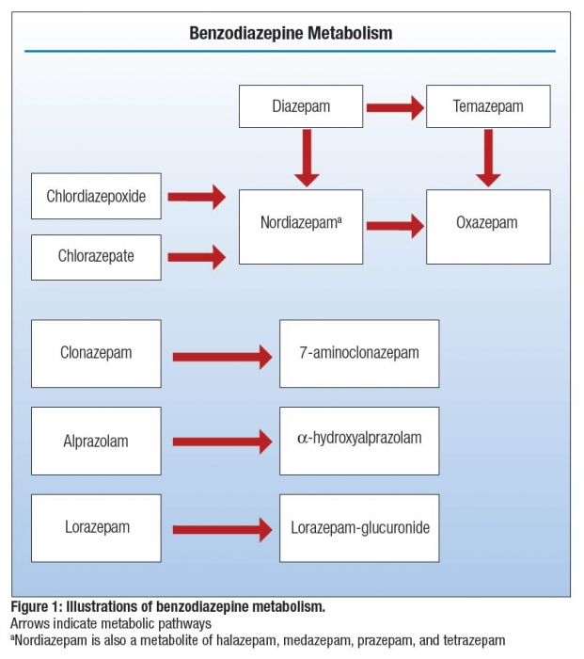

Figure 2: Benzodiazepine metabolism, arrows indicate metabolic pathways (Craven et al., 2014).

BDZs are positive allosteric modulators of the γ-amino butyric acid type A receptors (GABAA). The drug enhances response to the inhibitory neurotransmitter GABA, by opening GABA-activated chloride channels and allowing chloride ions to enter the neuron, making the neuron negatively charged and resistant to excitation, resulting in impaired cognition (Tan et al., 2011; Griffin et al., 2013). In plants GABA has been related to adverse environmental conditions, salt stress, ethylene production, carbon–nitrogen balance and ROS scavenging (Kinnersley and Turano, 2000; Shelp et al., 2012; Akçay et al., 2012). We will examine possible interaction of BZDs with plant GABA receptors, chloride and other ion concentrations and plant physical parameters that could be affected by exposure to these compounds. We will also quantify GABA and other possible biomarkers that could improve our understanding of how these drugs interact in the biochemical pathways of plants. Experiments will examine the interactions of these compounds in plants in relation to environmental stress and if these compound can affect plant response to stress.

1. **Preliminary results**
   1. **Pharmaceutical effect on plant growth**

Hydroponic studies were conducted to examine the effect of carbamazepine, lamotrigine and their combination on cucumber and sorghum plants. The crops were grown in hydroponic solutions containing 1 mg/L of carbamazepine, lamotrigine or both. Sorghum plants exposed to these treatments were affected in terms of plant biomass (Fig. 3). The plants also showed significant differences in nutrient content (Figs. 4 and 5). Similar trends were shown for cucumber plants.

Figure 3: Sorguhm plant biomass weight in response to pharmaceutical treatment (A); and percent difference between exposed plants to control (B). Significant differences according to Student T test.

Figure 4: Macro nutrient content of selected nutrients for sorguhm plants exposed to carbamazpine and lamotrigne.

Figure 5: Micro nutrient content of sorguhm plants exposed to carbamazpine and lamotrigne.

* 1. **Concentration dependent effect**

Under a hydroponic setup cucumber plants were exposed to different concentrations of lamotrigine. At the end of the experiment, 22 d after plants were transfer to glass jars, plants were decapitated at the base below the first real leaves and xylem sap was extracted. During the experiment sampling of the solution enabled quantification of lamotrigine and nutrient concentrations. Plants were also measured for differences in growth parameters. Although there were no significant differences in root or shoot weight there was a significant difference in the root to shoot ratio between the control and plants exposed to over 0.5 mg/L of lamotrigine. Furthermore, higher root to shoot ratios of nutrient concentration were measured for plants exposed to higher concentration of lamotrigine (Fig. 6). These results may suggest that lamotrigine affects the ion uptake by plants. Measurements of xylem sap resulted in similar translocation stream concentration factors (TSCF) regardless of nutrient solution concentration with an average value of 0.39 ±1.2 for all treatments. The different treatments were statistically similar. The TSCF of lamotrigine in this experiment was in the same range in comparison to additional experiments done in this study. In contrast the TSCF of carbamazepine was 0.88 ±0.3.

Figure6: ratio of nutrient concentration between root to shoot concentration.

1. **Objectives**

The objective of this study is to elucidate uptake, translocation and metabolism of psychoactive drugs (i.e., pharmokinetics) by agricultural crops and to examine the physiological effects that psychoactive drugs may have on plants (i.e., pharmodynamics).

Specific Objectives:

1. Study plant uptake, translocation and accumulation (i.e., pharmokinetics) of psychoactive drugs.
2. Examine the concentration dependent physiological effects that psychoactive drugs have on plants (pharmodynamics).
3. Evaluate drug-drug interactions affecting uptake by plants.
4. **Research plan: Rationale and Hypotheses** 
   1. **Pharmokinetics: Uptake, translocation and metabolism of benzodiazepines and psychoactive pharmaceuticals.**

Pharmokinetics examines the fate of substances in the plant. Hydroponic experiments will be conducted to examine the translocation of BZDs and AEDs in different crops such as tomato, cucumber, maize and sorghum. The relationship between compound physiochemical parameters will be evaluated in relation to root uptake, translocation and metabolism. We hypothesize that uptake and metabolism of psychoactive drugs depends on their physicochemical properties, plant physiology and environmental factors. We expect compounds that are capable of crossing the blood-brain barrier through passive diffusion to also be able to cross the casparian strip and thus be translocated to the leaves/fruit, and probably affect plant physiology and be affected by plant metabolic processes. Based on the first set of results, additional experiments will examine the drug–drug interaction and evaluate how different compounds interact with each other and influence each other's uptake, translocation or metabolism. In the human body drugs may be metabolized by similar enzymes and are often given in combination to improve drug efficiency. Hence, we hypothesize that compounds will affect the uptake, translocation and metabolism of one another and may increase or decrease the physiological effect of each other. We predict to see differences in plant response to combination exposure and differences in parent compound to metabolite ratios.

* 1. **Pharmodynamics: Concentration dependent effects of benzodiazepines and psychoactive pharmaceuticals of plants.**

Pharmacodynamics examines the biochemical and physiological effects of a compound on the plant. Hydroponic experiments will examine the dose-response of selected compounds on different plants. Based on which compounds are translocated and their activity, compounds (Fig.1) will be selected and will be exposed at 5 different concentrations in order to evaluate concentration dependent effects of the compound on the plant. We also hypothesize that these compounds can interact with the plant biochemical processes and influence plant physiology. We also hypothesize that antiepileptic drugs will interact with ion channels, affect the membrane potential and result in changes in the plant nutrient balance. Benzodiazepines interact with the GABA chloride channel; hence we hypothesize that these compounds will effect chloride concentrations, GABA concentrations, plant nutrient balance and plant growth. We hypothesize that these compounds can have similar mechanistic affects in plants as in mammals and will therefore effect ion concentrations and accumulation. Plants will be analyzed for compound concentrations, nutrient content, plant growth parameters, plant hormones and biomarkers.

1. **Methods and Materials** 
   1. **Choice of plants**

The experiments will use a variety of plants in order to test the potential uptake, translocation and metabolism of the selected compounds. Vegetables crops (cucumbers and tomatoes) and grains (maize, wheat and sorghum) will be used in this study. The vegetable species provide a representation of crops that are irrigated with treated wastewater and will be related to possible human health risks. However, current data regarding uptake and metabolism of xenobiotic by these crops is minimal and comparisons to other compounds are limited. Grains represent a family of plants for which there is ample data regarding uptake, translocation and metabolism of pesticide, hence providing data for comparison. The cucumber, tomato and wheat are all C3 plants while maize and sorghum are C4 plants, the differences between these species include higher rate of photosynthesis, higher growth rates, greater biomass and tolerance to stress conditions which is related to different enzyme activity among C4 plants and (Pearcy and Ehleringer, 1984; Nayyar and Gupta, 2006). Therefore differences in uptake, translocation and metabolism should be tested among different plant species. Cucumber and tomato plants will be the primary plants used in pharmodynamics experiments due to the ability to collect xylem sap from these species. The two plant species will be used as model plants for the research.

* 1. **Hydroponic experiments**

Crops will be grown in aerated nutrient solution under greenhouse conditions. The nutrient solution contains the following macronutrient concentrations (mM): K2SO4, 0.1; KCl, 1.6; Ca (NO3)2, 4.0; MgSO4, 2; KH2PO4, 0.5, and the following micronutrient composition (µM): Fe-EDTA, 50; MnSO4:H2O, 0.5; ZnSO4:7H2O, 0.5; CuSO4, 0.2; (NH4)6Mo7O24:4H2O, 0.07; H3BO3, 10. The nutrient solution will be changed every 3-5 days. The different treatments and concentrations will be conducted as 5 replicates. Xylem sap will be collected from C3 plants. Xylem sap is collected using a vacuum pump and a pressure regulator set at 0.8 bar.

* 1. **Extraction**

Compound extraction will be conducted according to previously developed methods which are referred to in Goldstein et al. (2014) and Malchi et al. (2014). In short, freeze-dried plant materials will be ground and extracted with an accelerated solvent extractor. The extraction is evaporated and reconstituted and followed by sample clean up prior to chromatographic analysis.

* 1. **Analysis**

Quantification of BZDs and AEDs will be performed using a reversed-phase HPLC (Waters Milford, USA). A Kinetex® Biphenyl 100 Å LC Column (100 x 4.6 mm, particle size 5 µm) will be used with a UV-spectrophotometric detector set at 307 nm. The injections will be carried out through a 50 µL loop and a flow rate of 1.0 mL/min. The mobile phase will be composed of a gradient mixture of methanol (0.1% formic acid) and water (0.1% formic acid). Lower concentrations of compounds will be analyzed using Agilent 1200 Rapid Resolution LC system (Agilent Technologies Inc., Santa Clara, CA) equipped with a Gemini C-18 column (150 × 2 mm, 3-µm particle size; Phenomenex, Torrance, CA, USA), coupled to an Agilent 6410 triple quadruple mass spectrometer with ESI ion source (Agilent Technologies Inc., Santa Clara, CA). A binary gradient of 1.5% acetic acid in deionized water and 0.05% acetic acid in acetonitrile will be used as the mobile phase (Malchi et al., 2014).

Plant nutrient content will be analyzed using an Inductively Coupled Plasma Atomic Emission Spectrometer (ICP-AES, Spectro ARCOS-SOP), following block digestion according to Klara 1998.Chlorophyll extraction will be determined according to Moran et al., 1980. Gamma Aminobutyric Acid (GABA) will be quantified using reversed phase HPLC equipped with a GeminiC18 110 Å, LC Column (150 x 4.6 mm, 5 μm) and a mobile phase of Acetonitrile/Methanol/Water (45:45:10). GABA will be detected at 340 nm. Plant hormones, auxin, cytokinins, gibberlin and Jasmonate will also be analyzed and quantified using the reverse-phased HPLC or LCMS (Pan et al., 2010; Böttcher et al., 2010). The research will also develop tools and procedures for measurements of plant xylem sap from young plants and from branches of older plants. A chlorophyll fluorometers will be used to measure photosynthetic performance and effects on PSII (Maxwell, 2000). Leaf hydraulic conductance, the ratio of the water flow rate through the leaf to the water potential gradient driving force for water movement across the leaf will be measured using the evaporative flux method (Sack and Scoffoni, 2012).

1. **Works cited**

Akçay, N., M. Bor, T. Karabudak, F. Ozdemir, and I. Türkan. 2012. Contribution of Gamma amino butyric acid (GABA) to salt stress responses of Nicotianasylvestris CMSII mutant and wild type plants. J. Plant Physiol. 169(5): 452–458.

Banks, W.A. 2009.Characteristics of compounds that cross the blood-brain barrier. BMC Neurol. 9(suppl):S3.

Behera, S.K., H.W. Kim, J.-E. Oh, and H.-S. Park. 2011. Occurrence and removal of antibiotics, hormones and several other pharmaceuticals in wastewater treatment plants of the largest industrial city of Korea. Sci. Total Environ. 409(20): 4351–4360.

Bergman, S. 2014. Medic, Monthly ethical drug index compilation. Shirol Publications LTD. Hertzilia.

Bernus, I., R.G. Dickinson, W.D. Hooper, and M.J. Eadie. 1997. The mechanism of the carbamazepine-valproate interaction in humans. Br. J. Clin. Pharmacol. 44(1): 21–27.

Böttcher, C., Burbidge, C. A., di Rienzo, V., Boss, P. K., & Davies, C. 2015. Jasmonic acid-isoleucine formation in grapevine (Vitis vinifera L.) by two enzymes with distinct transcription profiles. J Integr Plant Biol, 57(7): 618–27.

Briggs, G.G., R.H. Bromilow, and A.A. Evans. 1982. Relationships between lipophilicity and root uptake and translocation of non-ionised chemicals by barley. Pestic. Sci. 13(5): 495–504.

Brodin, T., J. Fick, M. Jonsson, and J. Klaminder. 2013. Dilute concentrations of a psychiatric drug alter behavior of fish from natural populations. Science 339(6121): 814–825.

Brooks, B.W., P.K. Turner, J.K. Stanley, J.J. Weston, E.A. Glidewell, C.M. Foran, M. Slattery, T.W. La Point, and D.B. Huggett. 2003. Waterborne and sediment toxicity of fluoxetine to select organisms. Chemosphere 52(1): 135–142.

Carter, L.J., M. Williams, C. Böttcher, and R.S. Kookana. 2015. Uptake of Pharmaceuticals influences plant development and affects nutrient and hormone homeostases. Environ. Sci. Technol. 49(20): 12509–12518.

Cascade, E., A. Kalali, and R. Weisler. 2008. Varying uses of anticonvulsant medications. Psychiatry 5: 31–43.

Chen, T., X. Cai, X. Wu, I. Karahara, L. Schreiber, and J. Lin. 2011. Casparian strip development and its potential function in salt tolerance. Plant Signal.Behav. 6(10): 1499–502.

Clara, M., B. Strenn, O. Gans, E. Martinez, N. Kreuzinger, and H. Kroiss. 2005. Removal of selected pharmaceuticals, fragrances and endocrine disrupting compounds in a membrane bioreactor and conventional wastewater treatment plants. Water Res. 39(19): 4797–4807.

Craven, C., M. Fileger, and P. Woster. 2014. Demystifying benzodiazepine urine drug screen results. Pract Pain Manage. 14(1):38-41.

Curry, W.J., and D.L. Kulling. 1998. Newer antiepileptic drugs: gabapentin, lamotrigine, felbamate, topiramate and fosphenytoin. Am. Fam. Physician 57(3): 513–520.

Enstone, D.E., C. a. Peterson, and F. Ma. 2003. Root Endodermis and Exodermis: Structure, Function, and Responses to the Environment. J. Plant Growth Regul. 21(4): 335–351.

Eyal, S., P. Hsiao, and J.D. Unadkat. 2009. Drug interactions at the blood-brain barrier: fact or fantasy? Pharmacol.Ther. 123(1): 80–104.

FDA. 2013. Anticonvulsant Medications: U.S. Food and Drug Administration-Approved Indications and Most Common Dosages for Use in Adults. *CMS*. (1), 1–6.

Goldstein, M., M. Shenker, and B. Chefetz. 2014. Insights into the uptake processes of wastewater-borne pharmaceuticals by vegetables. Environ. Sci. Technol. 48(10): 5593–5600.

Gracia-Lor, E., J. V Sancho, R. Serrano, and F. Hernández. 2012. Occurrence and removal of pharmaceuticals in wastewater treatment plants at the Spanish Mediterranean area of Valencia. Chemosphere 87(5): 453–462.

Griffin, C.E., A.M. Kaye, F.R. Bueno, and A.D. Kaye. 2013. Benzodiazepine pharmacology and central nervous system-mediated effects. Ochsner J. 13(2): 214–223.

Hass, U., U. Duennbier, and G. Massmann. 2012. Occurrence and distribution of psychoactive compounds and their metabolites in the urban water cycle of Berlin (Germany). Water Res. 46(18): 6013–6022.

Hsu, F.C., R.L. Marxmiller, and A.Y. Yang. 1990. Study of root uptake and xylem translocation of cinmethylin and related compounds in detopped soybean roots using a pressure chamber technique. Plant Physiol. 93(4): 1573–1578.

Jelic, A., M. Gros, A. Ginebreda, R. Cespedes-Sánchez, F. Ventura, M. Petrovic, and D. Barcelo. 2011. Occurrence, partition and removal of pharmaceuticals in sewage water and sludge during wastewater treatment. Water Res. 45(3): 1165–1176.

Kasprzyk-Hordern, B., R.M. Dinsdale, and A.J. Guwy. 2009. The removal of pharmaceuticals, personal care products, endocrine disruptors and illicit drugs during wastewater treatment and its impact on the quality of receiving waters. Water Res. 43(2): 363–380.

Kim, S.D., J. Cho, I.S. Kim, B.J. Vanderford, and S.A. Snyder. 2007. Occurrence and removal of pharmaceuticals and endocrine disruptors in South Korean surface, drinking, and waste waters. Water Res. 41(5): 1013–1021.

Kinnersley, A.M., and F.J. Turano. 2000. Gamma Aminobutyric Acid (GABA) and Plant Responses to Stress. CRC. Crit. Rev. Plant Sci. 19(6): 479–509.

Lasoń, W., M. Dudra-Jastrzębska, K. Rejdak, and S.J. Czuczwar. 2011. Basic mechanisms of antiepileptic drugs and their pharmacokinetic/pharmacodynamic interactions: an update. Pharmacol. Rep. 63(2): 271–292.

Laterra, J., Keep, R., Betz, L. A., & Goldstein, G. W. 1999. Blood—Brain Barrier. Lippincott-Raven.

Liu, W.-Y., Z.-B. Wang, L.-C. Zhang, X. Wei, and L. Li. 2012. Tight junction in blood-brain barrier: an overview of structure, regulation, and regulator substances. CNS Neurosci. Ther. 18(8): 609–615.

Malchi, T., Y. Maor, G. Tadmor, M. Shenker, and B. Chefetz. 2014. Irrigation of root vegetables with treated wastewater: evaluating uptake of pharmaceuticals and the associated human health risks. Environ. Sci. Technol. 48(16): 9325–9333.

Maxwell, K. 2000. Chlorophyll fluorescence--a practical guide. Journal of Experimental Botany, 51(345), 659–668.

Miège, C., E. Paoletti, J.M. Choubert, L. Ribeiro, M. Eusèbe, and M. Coquery. 2009. Fate of pharmaceuticals and personal care products in wastewater treatment plants – Conception of a database and first results. Environ. Pollut. 157(5): 1721–1726.

Nayyar, H., & Gupta, D. 2006. Differential sensitivity of C3 and C4 plants to water deficit stress: Association with oxidative stress and antioxidants. Environ Exp Bot, 58(1-3): 106–113.

Nakada, N., T. Tanishima, H. Shinohara, K. Kiri, and H. Takada. 2006. Pharmaceutical chemicals and endocrine disrupters in municipal wastewater in Tokyo and their removal during activated sludge treatment. Water Res. 40(17): 3297–3303.

O’brien, C.P. 2005. Benzodiazepine use, abuse, and dependence. J. Clin. Psychiatry 66 Suppl 2: 28–33.

Oggier, D.M., C.J. Weisbrod, A.M. Stoller, A.K. Zenker, and K. Fent. 2010. Effects of diazepam on gene expression and link to physiological effects in different life stages in zebrafish Danio rerio. Environ. Sci. Technol. 44(19): 7685–7691.

Pan, X., Welti, R., & Wang, X. 2010. Quantitative analysis of major plant hormones in crude plant extracts by high-performance liquid chromatography-mass spectrometry. Nat Protoc, 5(6): 986–92.

Pearcy, R.W., and J. Ehleringer. 1984. Comparative ecophysiology of C3 and C4 plants. Plant, Cell Environ. 7(1): 1–13.

Sack, L., & Scoffoni, C. 2012. Measurement of leaf hydraulic conductance and stomatal conductance and their responses to irradiance and dehydration using the Evaporative Flux Method (EFM). Journal of Visualized Experiments : JoVE, (70), e4179.

Salem, A.A., B.N. Barsoum, and E.L. Izake. 2004. Spectrophotometric and fluorimetric determination of diazepam, bromazepam and clonazepam in pharmaceutical and urine samples. Spectrochim.Acta. A. Mol. Biomol. Spectrosc. 60(4): 771–780.

Shelp, B.J., R.T. Mullen, and J.C. Waller. 2012. Compartmentation of GABA metabolism raises intriguing questions. Trends Plant Sci. 17(2): 57–59.

Sirven, J.I., K. Noe, M. Hoerth, and J. Drazkowski. 2012. Antiepileptic drugs 2012: recent advances and trends. Mayo Clin. Proc. 87(9): 879–889.

Subedi, B., and K. Kannan. 2015. Occurrence and fate of select psychoactive pharmaceuticals and antihypertensives in two wastewater treatment plants in New York State, USA. Sci. Total Environ. 514: 273–280.

Sui, Q., J. Huang, S. Deng, W. Chen, and G. Yu. 2011. Seasonal variation in the occurrence and removal of pharmaceuticals and personal care products in different biological wastewater treatment processes. Environ. Sci. Technol. 45(8): 3341–3358.

Tan, K.R., U. Rudolph, and C. Lüscher. 2011. Hooked on benzodiazepines: GABAA receptor subtypes and addiction. Trends Neurosci. 34(4): 188–197.

Thomas, M.A., and R.D. Klaper. 2012. Psychoactive pharmaceuticals induce fish gene expression profiles associated with human idiopathic autism. PLoS One 7(6): e32917.

Van de Waterbeemd, H., G. Camenisch, G. Folkers, J.R. Chretien, and O.A. Raevsky. 1998. Estimation of blood-brain barrier crossing of drugs using molecular size and shape, and H-bonding descriptors. J. Drug Target. 6(2): 151–165.

Vranova, V., K. Rejsek, K.R. Skene, D. Janous, and P. Formanek. 2013. Methods of collection of plant root exudates in relation to plant metabolism and purpose: A review. J. Plant Nutr. Soil Sci. 176(2): 175–199.

Warner, T., P.N. Patsalos, M. Prevett, A.A. Elyas, and J.S. Duncan. 1992. Lamotrigine-induced carbamazepine toxicity: an interaction with carbamazepine-10,11 -epoxide. Epilepsy Res. 11(2): 147–150.

Wick, A., G. Fink, A. Joss, H. Siegrist, and T. a Ternes. 2009. Fate of beta blockers and psycho-active drugs in conventional wastewater treatment. Water Res. 43(4): 1060–74.

World Health Organization. 2005. Atlas: Epilepsy Care in the World. Geneva, Switzerland.

Yu, J.T., E.J. Bouwer, and M. Coelhan. 2006. Occurrence and biodegradability studies of selected pharmaceuticals and personal care products in sewage effluent. Agric. Water Manag. 86(1-2): 72–80.